OBJECTIVE: To perform static simulation using material whose E=3000Mpa and Poisson Ratio=0.28, Fix one Face and apply Remote Force at 1/3rd of that Fixed face, having Magnitude=Your Date of birth (e.g. 12/Feb/1999 = 12+2+1999=2013) and show Mesh convergence.
STEPS:
- Open Ansys workbench and create a new project. Drag the “Static Structural” system into the project workspace.
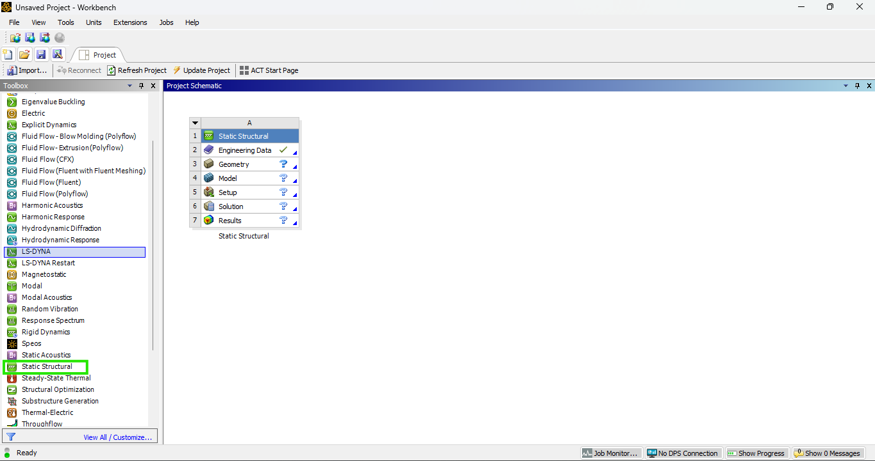

- Go to “Engineering Data” and click on add a new material name it as “Custom Material” and define properties such as Youngs Modulus=3000Mpa and Poisson Ratio=0.28 and delete predefined structural steel. 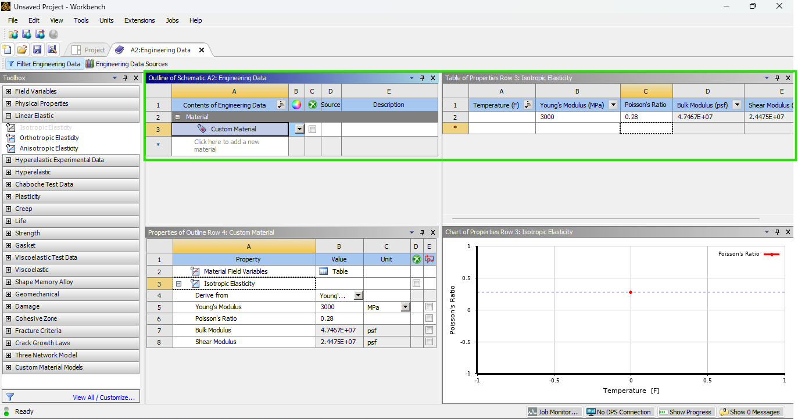
- Double Click on geometry to open the geometry editor Design Modeler. Create a Hexagon in sketching option, extrude it and assign its length=20metre.

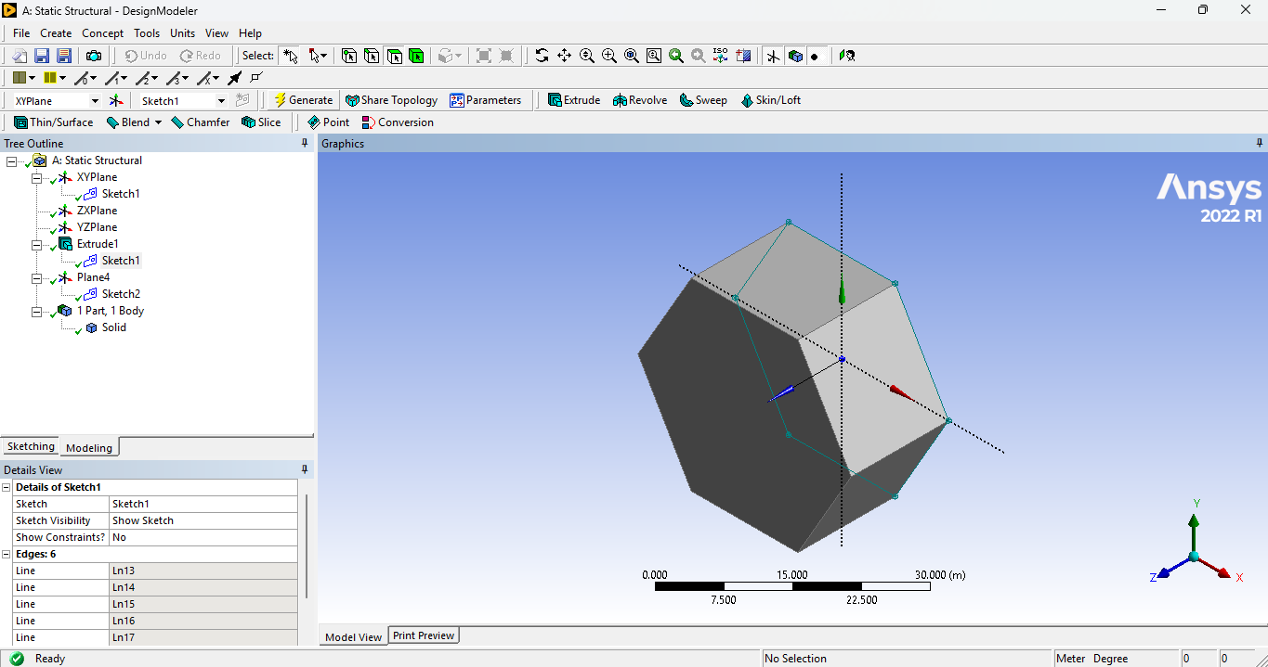

- Double Click on model to enter the Mechanical Interface. Under the “Mesh Section”, Use “Generate Mesh” to create meshing and give sizing and mesh type e.g. (tetrahedron or hexahedron) if necessary.

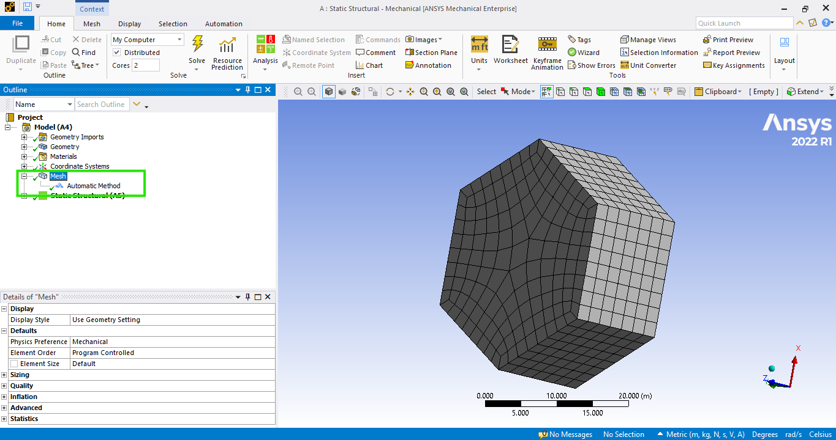

- Apply Boundary Conditions “Fixed support” at the bottom face and apply “Remote Force” at a distance of (1/3) of the length of hexagon to simulate loading conditions. 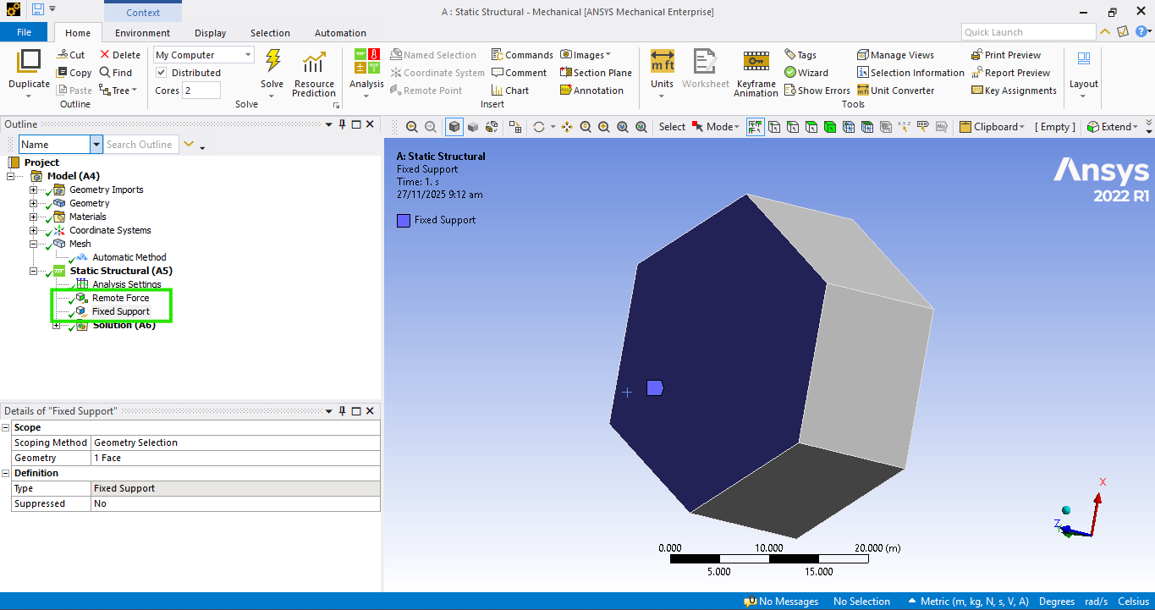

- In the “Solution” select “Total Deformation”, “Equivalent Stress” and “Equivalent Strain” to Calculate it. Now click on “Solve” to run the analysis, The software will compute the “Total Deformation”, “Equivalent Stress” and “Equivalent Strain” under given conditions. 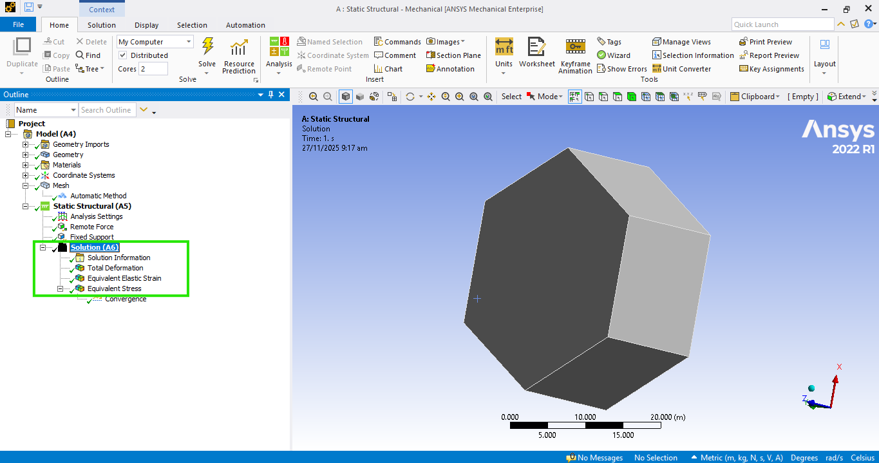

- Right-click on the Equivalent Stress object you just created in the tree. Select Insert > Convergence. In the Details window, look for Allowable Change (%). A standard value is 5% (for general engineering) or 1% (for high precision) change it to 15%, Set the Max Refinement Loops (e.g., 3 or 4). This prevents ANSYS from running forever if it can't converge.

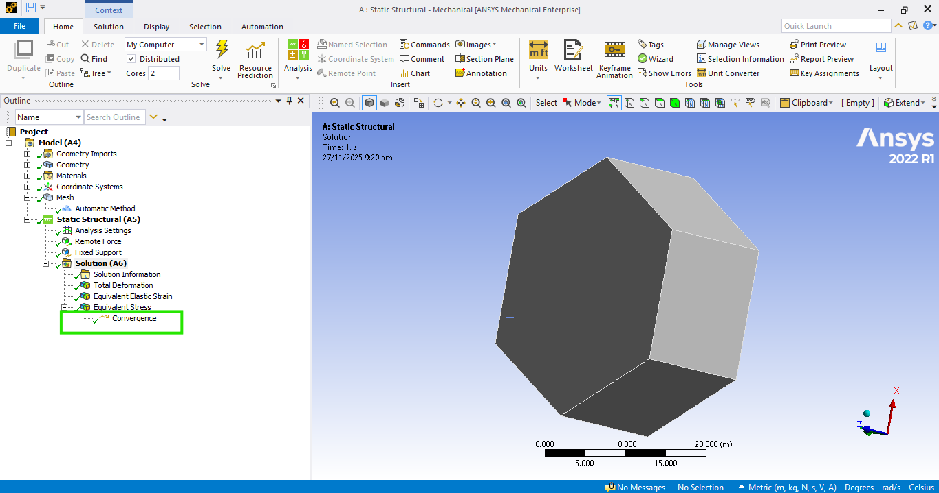

- Now click on “Solve” to run the analysis, The software will compute under given conditions. After Solution is complete view the results and convergence in the solution section.
Equivalent Stress
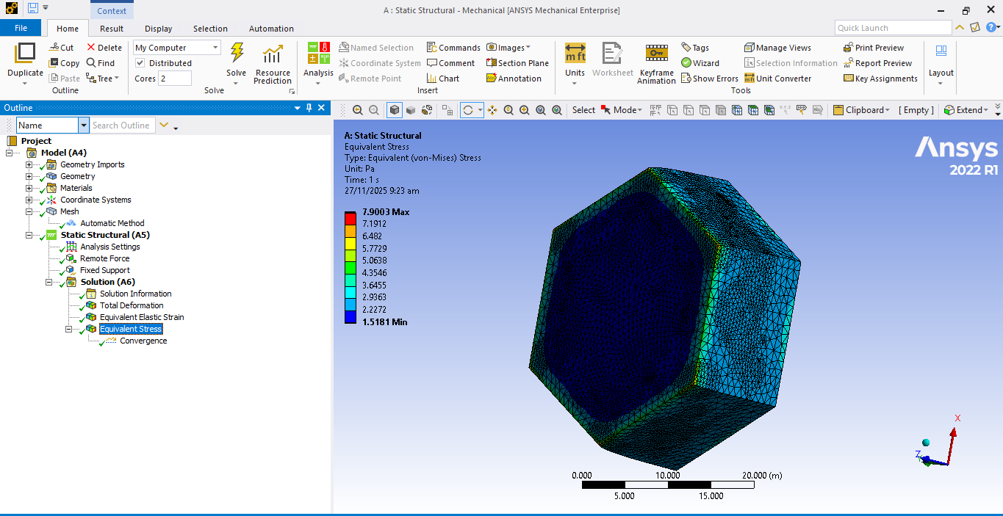

Convergence
